1) When to use (Rapid Application Development) RAD model
When not to use (Rapid Application Development) RAD model

RAD model is rarely practiced across different organisations in the modern world. It is similar to waterfall approach and to use it, certain criteria should be met. They are discussed below.
- RAD is used when a working software is required within a very short span of time. The quality may not be an issue to the client, he will care only if the development is done within the speciied time frame.
- RAD is a costly process. This means that the budget of the project should be sufficiently high so that automated code generating tools and skilled human resources can be involved.
- If the resources have a good business knowledge, then RAD can be preferred.
- RAD could be used where the requirements change during the course of the project and working prototypes are to be presented to the customer in small iterations of 2-3 months.
- If there are skilled designers and technicians, RAD can be chosen.

On the contrary, there are situations in which RAD model is not advisable at all. Such situations are as follows.

- If the time period provided is too large.
- If the quality of product is mandatory.
- If there is no active customer interaction.
- If resources with good business knowledge are not present.
- If there are no skilled technicians or designers.

2) Define an ER diagram of a software Organization with all the relationship
model that was discussed in the classroom

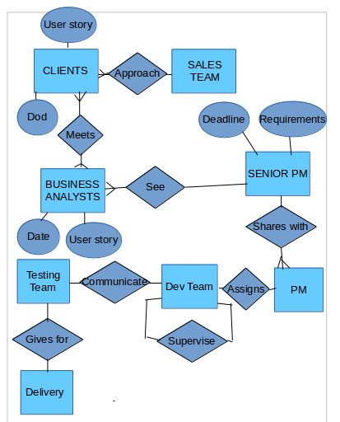

3) Describe the entity relations for the given diagram

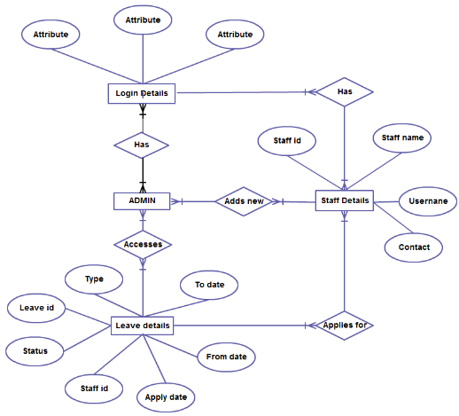
- The given image is the entity relationship diagram of the web portal of an organisation where different staff log in to apply for leave.
- The log in details will include different attributes represented inside ovals. These credentials may be user name, password, captcha code etc.
- The log in section of different staff will be controlled by multiple admins. This means that there is a many to many relation existing there.
- Each staff will have only a single log in credential. Also, every staff has log in credentials.Here there is a many to one relation.
- The staff can enter their details (attributes). The attributes related with the staff details are username,staff name, staff id etc.
- Multiple admins can add new staff details one by one(Many to many).
- Also, all the admins can access the leave details of the staff one by one(many to many).
- The attributes related with leave details include leave id, status, staff id etc.
- All the staff can access their leave details. That is the reason why there is a many to many relation between leave details and staff details.

